**Julia Programming**

1. Write a program to take input from the user and display the values. (name and ID Number)

**Code:**

print("Enter your Name : ");

name = readline();

print("Enter ID Number : ");

id = readline();

println("Name : ",name);

**Output:**

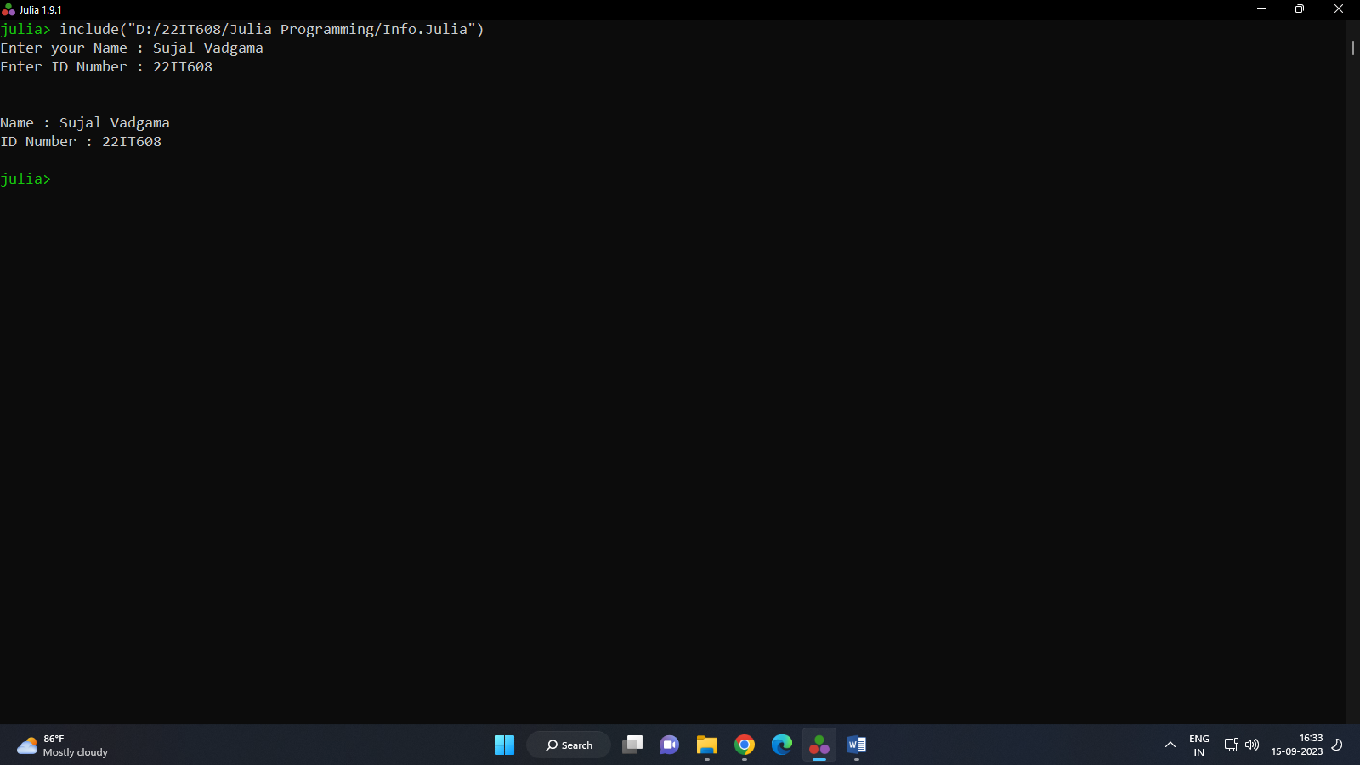

1. Write a program that takes input week number and print week day.

**Code:**

print("Enter Week Number : ");

num = parse(Int,readline(stdin))

if num==1

print("It's Monday");

elseif num == 2

print("It's Tuesday");

elseif num == 3

print("It's Wednesday");

elseif num == 4

print("It's Thursday");

elseif num == 5

print("It's Friday");

elseif num == 6

print("It's Saturday");

elseif num == 7

print("It's Sunday");

else

print("Invalid Input!!!\nPlease enter between (1 ~ 7)");

end

**Output:**

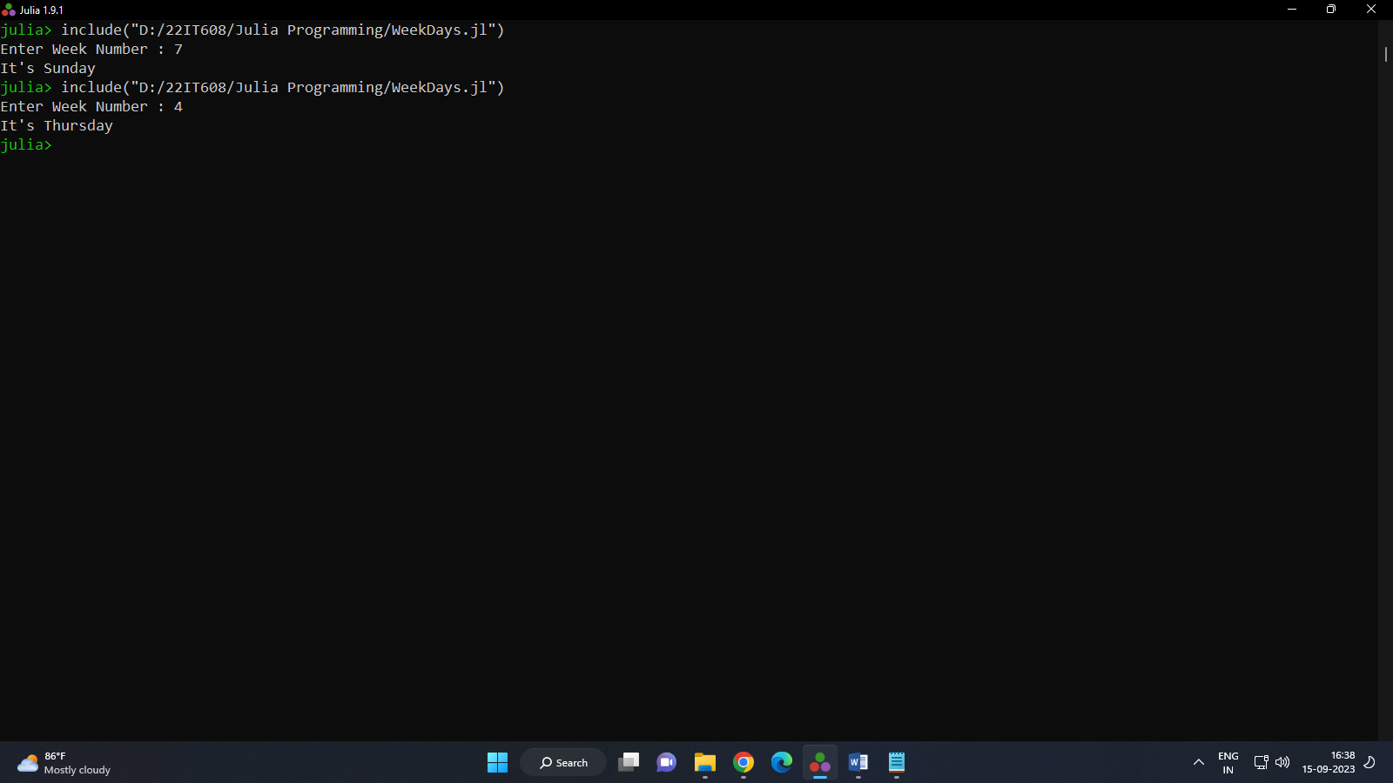

1. Write a program to check weather a number is even or odd.

**Code;**

print("Enter a number : ")

num = parse(Int,readline(stdin))

if num%2 == 0

print(num," is an even number!")

else

print(num," is an odd number!")

end

**Output:**

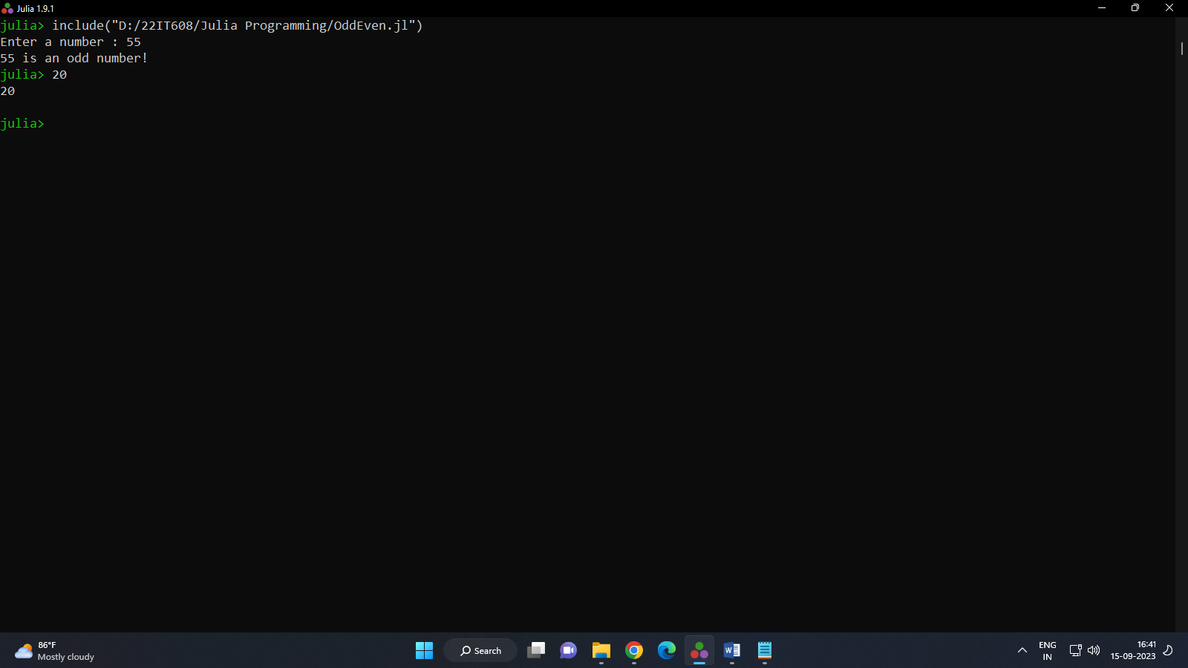

1. Write a program to check weather a year is leap or not.

**Code:**

print("Enter the year : ")

year = parse(Int,readline(stdin))

if year%4==0 && year%100 != 0 || year%400 == 0

print(year," is a leap year ! ")

else

print(year," is not a leap year ! ")

end

**Output:**

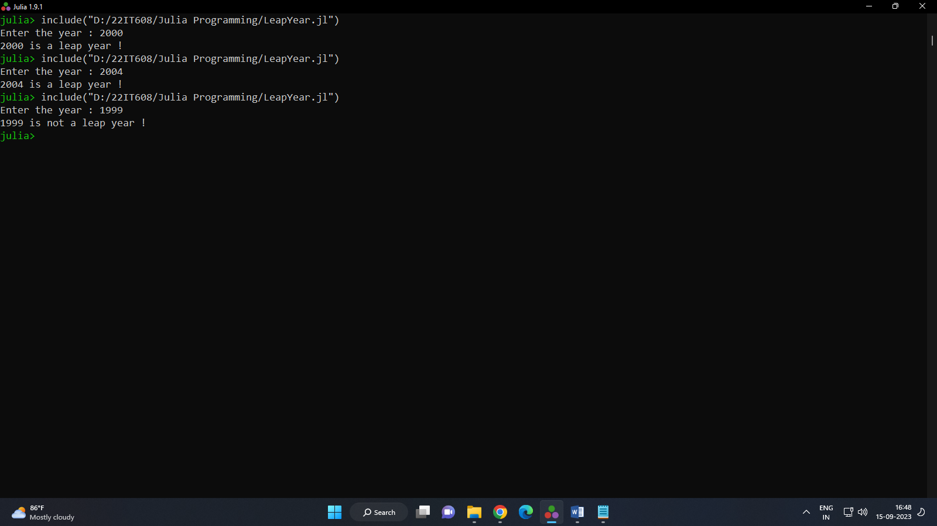

1. Write a program to input marks of four subjects Physics, Chemistry, Biology, and Mathematics. Calculate percentage and grade.

**Code:**

print("Enter your Name")

name = readline()

print("Enter marks of Physics : ")

phy = parse(Int,readline(stdin))

print("Enter marks of Chemistry : ")

chem = parse(Int,readline(stdin))

print("Enter marks of Biology ; ")

bio = parse(Int,readline(stdin))

print("Enter marks of Mathematics : ")

math = parse(Int,readline(stdin))

total = phy + chem + bio + math

avg = total/4

if avg>=90

print("\n\nName : ",name,"\nTotal ; ",total,"\nPercentage : ",avg,"%\nGrade : A")

elseif avg>=80

print("\n\nName : ",name,"\nTotal ; ",total,"\nPercentage : ",avg,"%\nGrade : B")

elseif avg>=70

print("\n\nName : ",name,"\nTotal ; ",total,"\nPercentage : ",avg,"%\nGrade : C")

elseif avg>=60

print("\n\nName : ",name,"\nTotal ; ",total,"\nPercentage : ",avg,"%\nGrade : D")

elseif avg>=40

print("\n\nName : ",name,"\nTotal ; ",total,"\nPercentage : ",avg,"%\nGrade : E")

else avg<40

print("\n\nName : ",name,"\nTotal ; ",total,"\nPercentage : ",avg,"%\nGrade : F")

end

**Output:**

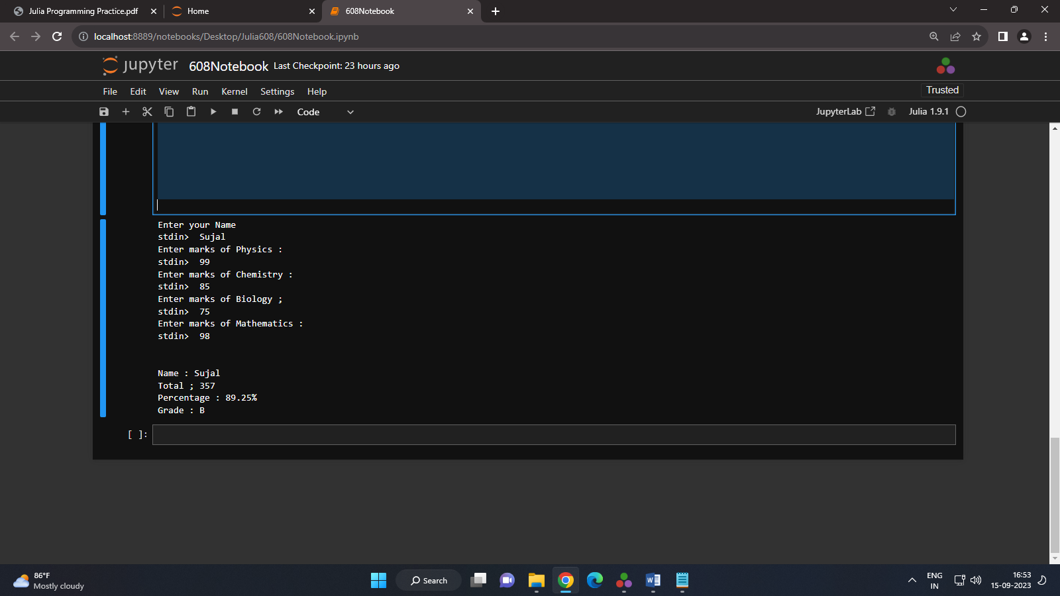

1. Write a program to make a Simple Calculator (using function).

**Code:**

function simplecalc(num1,num2)

print("\n\nAddition : ",num1+num2)

print("\nSubtraction : ",num1-num2)

print("\nMultiplication : ",num1*num2)

print("\nDivision : ",num1/num2)

print("\nModulo : ",num1%num2)

end

print("Enter Number 1 : ")

num1 = parse(Int,readline(stdin))

print("Enter Number 2 : ")

num2 = parse(Int,readline(stdin))

simplecalc(num1,num2)

**Output:**

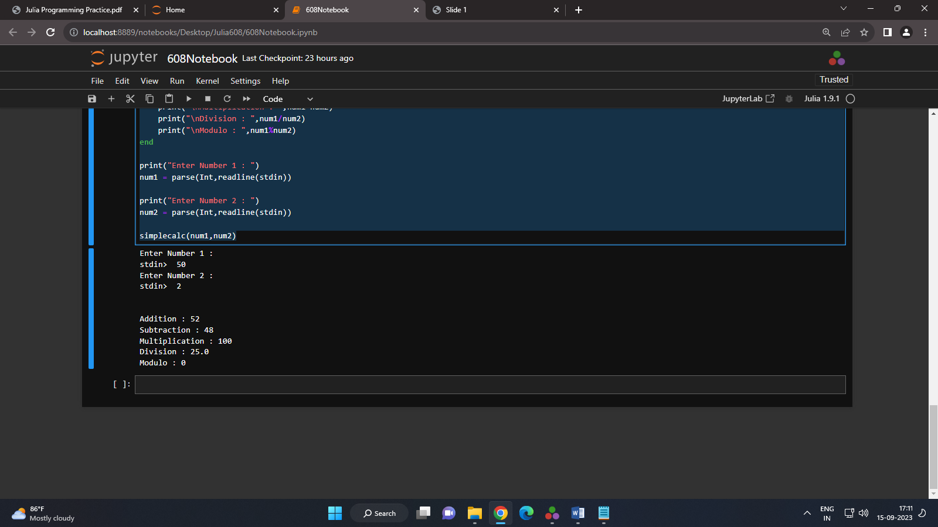

1. Write a program to find the maximum and the minimum value of a given vector (values: 5,10,20,23,39).

**Code:**

num = (5,10,20,23,39)

min = minimum(num)

max = maximum(num)

print("\nMaximum : ",max)

print("\nMinimum : ",min)

**Output:**

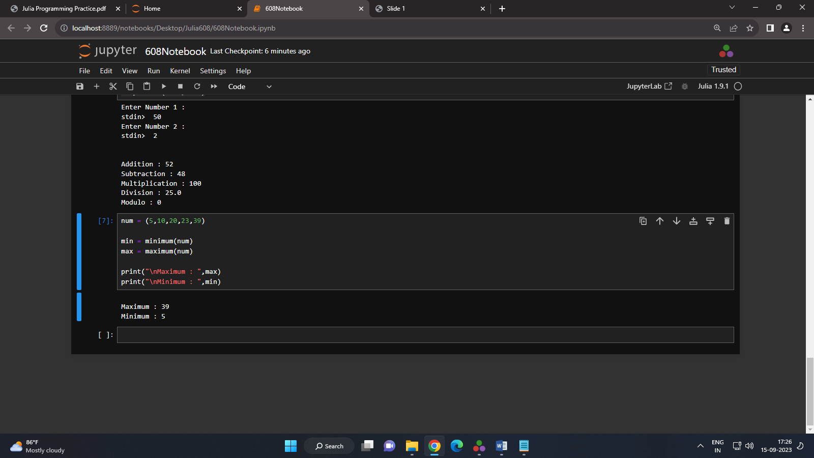

1. Write a program to get the first 5 Fibonacci numbers.

**Code:**

print("-----Fibonacci Series-----")

a = 0

b = 1

c = 0

itr = 2

print("\n",a," ",b)

while(itr<6)

global c = a + b

print(" ",c)

global a = b

global b = c

itr += 1

end

**Output:**

